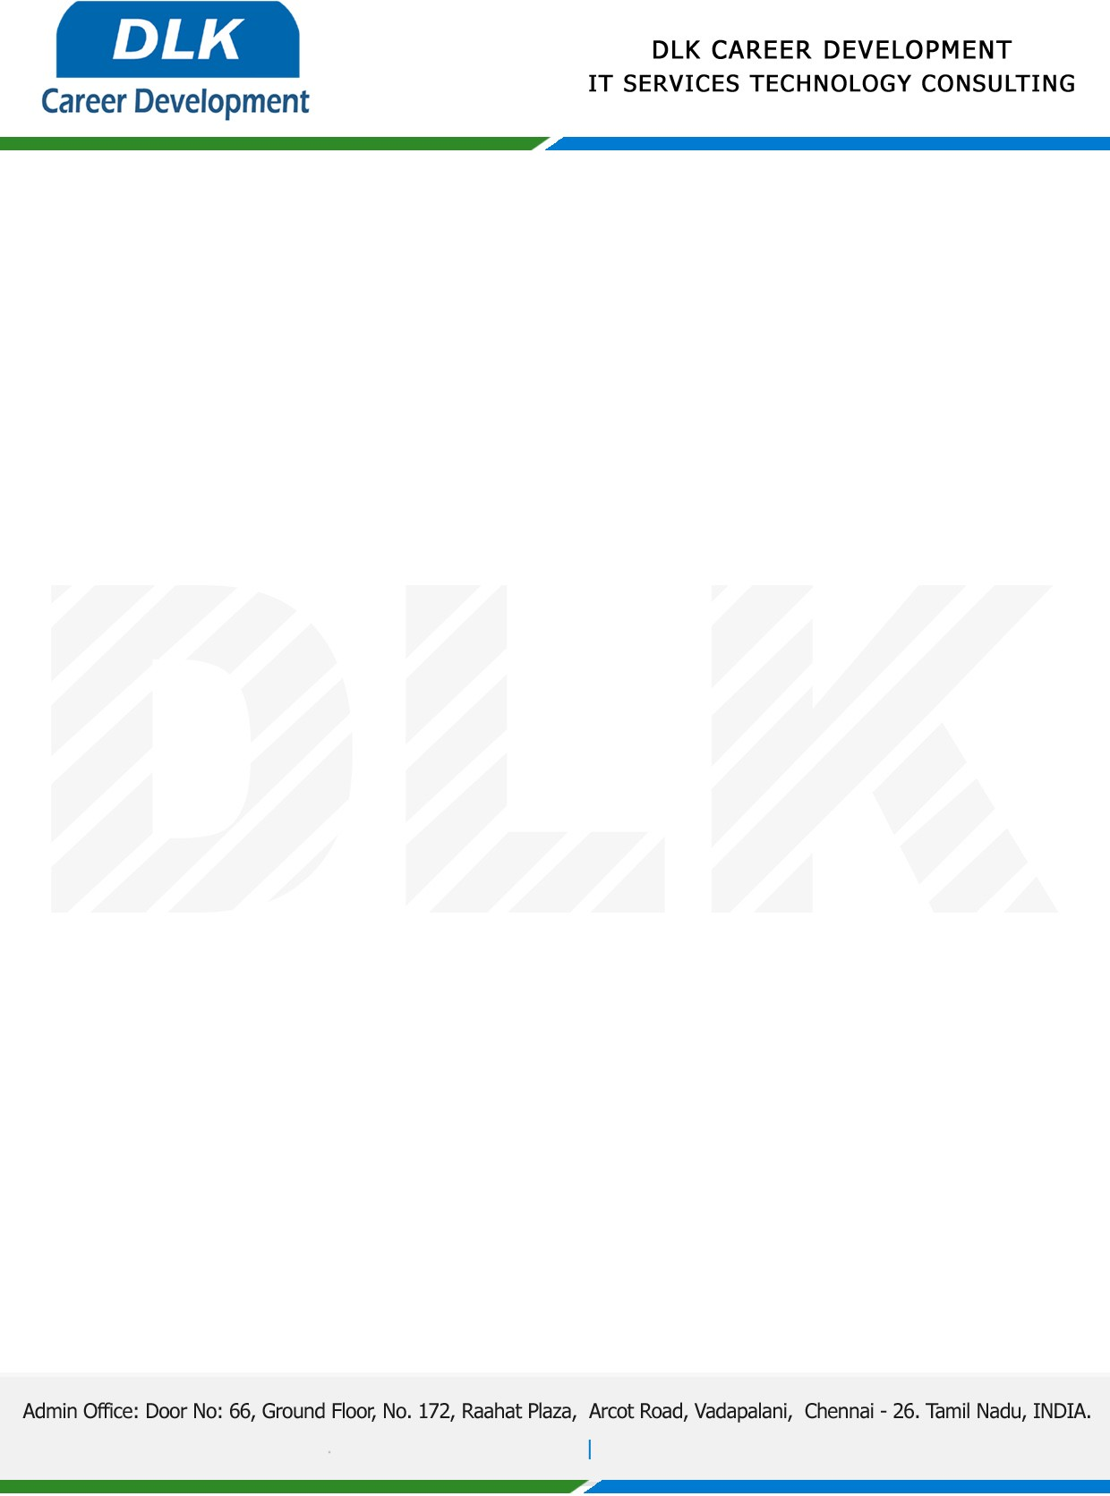

**Date: 17/ April /2023**

**SUB: PROJECT COMPLETION CERTIFICATE**

This is to certify that **MS HEMAKARTHIKA B (REG NO:** **832100389) MSC- Computer Science,** final year student **Valliammal College for Women, Chennai** has Successfully Completed the Project Work under the domain of “**Java”** in our organization during the Period **(January 2023 to May2023).**

**Topic:** A Light Weight Policy Update Scheme for Personal Health Record Sharing**.**

We appreciate your interest in **DLK CAREER DEVELOPMENT**

**“Best Wishes for Your Future Endeavors “**

